**DBMS Holiday Assignment Name: Sravan**

**Roll no: 2311CS020379(omega) TASK FROM LEETCODE:**

**1.Game Play Analysis (Solve it in LeetCode)**

|  |  |  |
| --- | --- | --- |
| **Table: Activity**  **Create a Activity table and Insert the given below values and Write a Query for below question**  **:-**   1. Write a solution to find the **first login date** for each player from table . 2. Return the result table in **any order**   The result format is in the following example. | | |
| **Example 1:** | |  |
| **Input:** |  | |
| y table:  + + + + +  + r_id | device_id | event_date | games_played |  + + + +  | 2 | 2016-03-01 | 5 |  | 2 | 2016-05-02 | 6 |  | 3 | 2017-06-25 | 1 |  | 1 | 2016-03-02 | 0 |  +------- | 4 | 2018-07-03 | 5 |  | + + + + | | |

**Ans:**

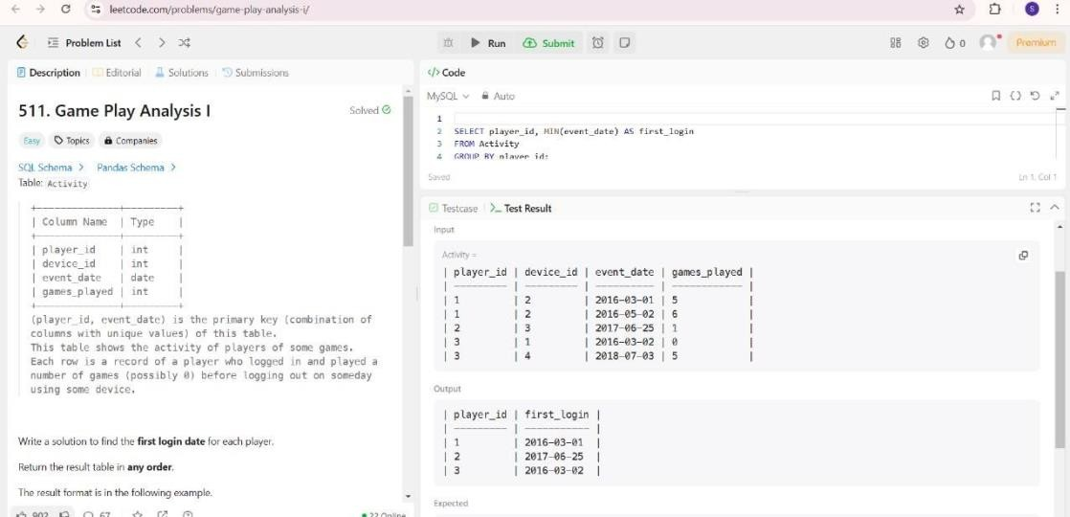

**TASK-2**

**Find Customer Referee(**(**Solve it in LeetCode**)

|  |  |  |  |  |  |
| --- | --- | --- | --- | --- | --- |
| Find the names of the customer that are | | | | **not referred by** | the customer with id = 2. |
|  | | | | | |
| Return the result table in | | **any order** | . | | |
| **Input:** |  | | | | |
| +----+  +----+  3 | | er table:  + +  me | referee_id |  + +  ill | null |  ne | null |  ex | 2 |  ll | null |  ck | 1 |  ark | 2 | |  |  |  |  |

**Ans.**

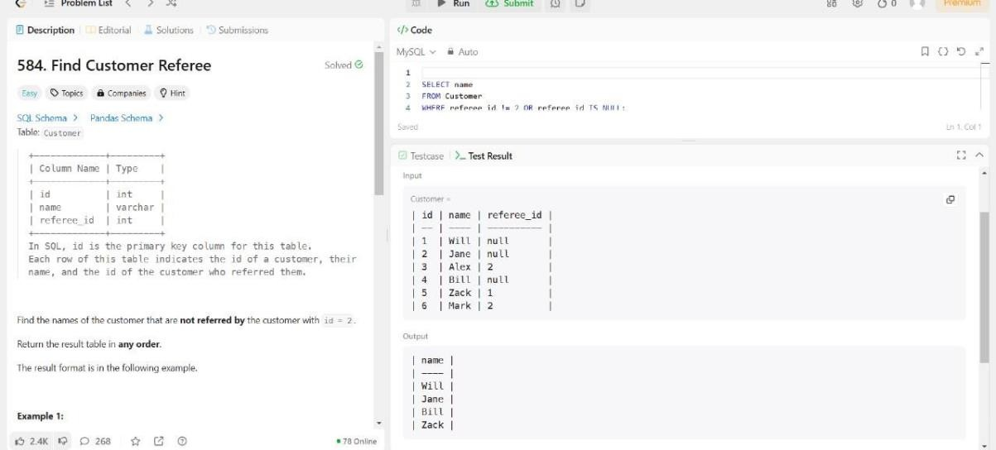

**TASK-3**

**Big Countries (Solve it in LeetCode**)

if:

* it has an area of at least three million (i.e., 3000000 km2), or
* it has a population of at least twenty-five million (i.e., 25000000). Write a solution to find the name, population, and area of the .

Return the result table in

.

World table:

+

| name

+

+

+

+

+

+

| continent | area | population | gdp

|

+

+

+

+

+

| Afghanistan | Asia | 652230 | 25500100 | 20343000000 |

**Input:**

**any order**

**big countries**

**big**

A country is

| Albania

| Algeria

| Andorra

| Angola

+

| Europe | 28748 | 2831741 | 12960000000 |

| Africa | 2381741 | 37100000 | 188681000000 |

| Europe | 468

| 78115

| 3712000000 |

| Africa | 1246700 | 20609294 | 100990000000 |

+

+

+

+

+

**Ans.**

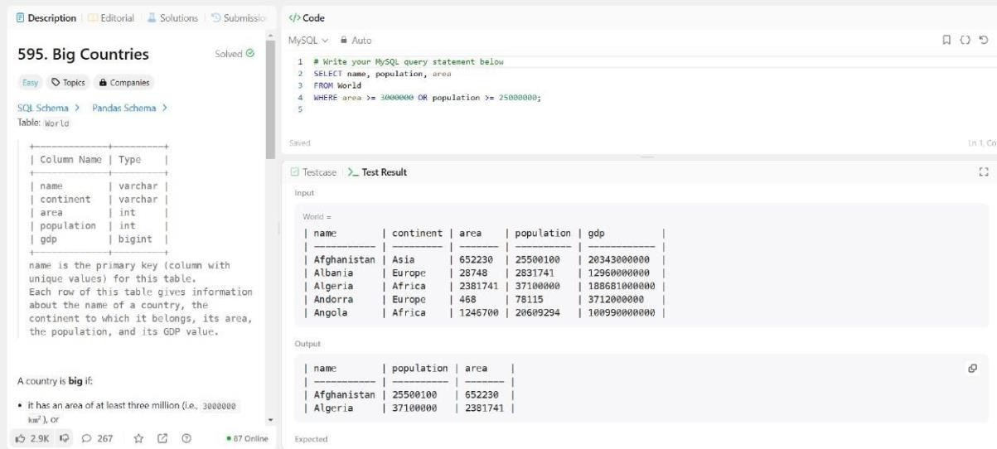

**TASK-4**

**Recyclable and low fat products (Solve it in LeetCode)**

|  |  |  |  |
| --- | --- | --- | --- |
| Write a solution to find the ids of products that are both low fat and recyclable. | | | |
| Return the result table in | | **any order** | . |
| **Input:** |  | | |
| cts table:  + + + +  ct_id | low_fats | recyclable |  + + + +  | Y | N |  | Y | Y |  | 2 | N | Y |  | Y | Y |  | N | N |  + + + + | | | |

**Ans.**

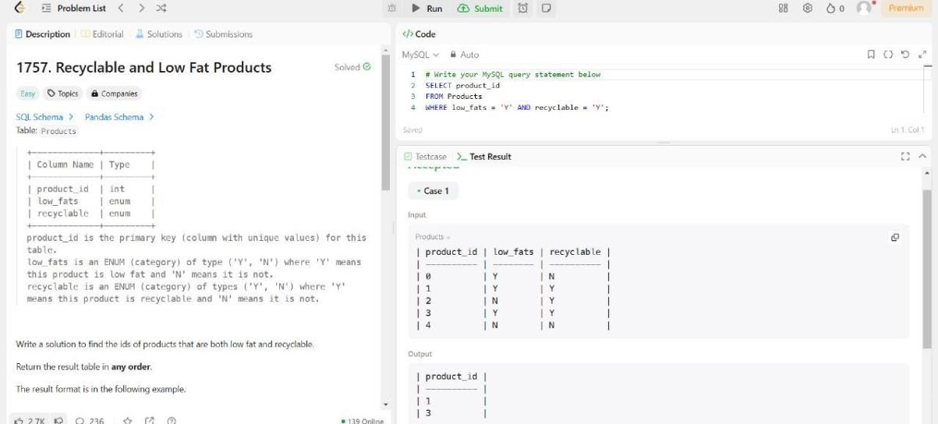

**TASK-5**

|  |  |  |  |  |
| --- | --- | --- | --- | --- |
| Write a solution to find the IDs of the invalid tweets. The tweet is invalid if the number of characters | | | | |
| used in the content of the tweet is | | **strictly** | than | 15. |
| **greater** |
| **Input:** |  | | | |
| s table:  + + +  _id | content |  + + +  | Let us Code |  | More than fifteen chars are here! | +-----------------------------------  + + | | | | |

**Ans.**

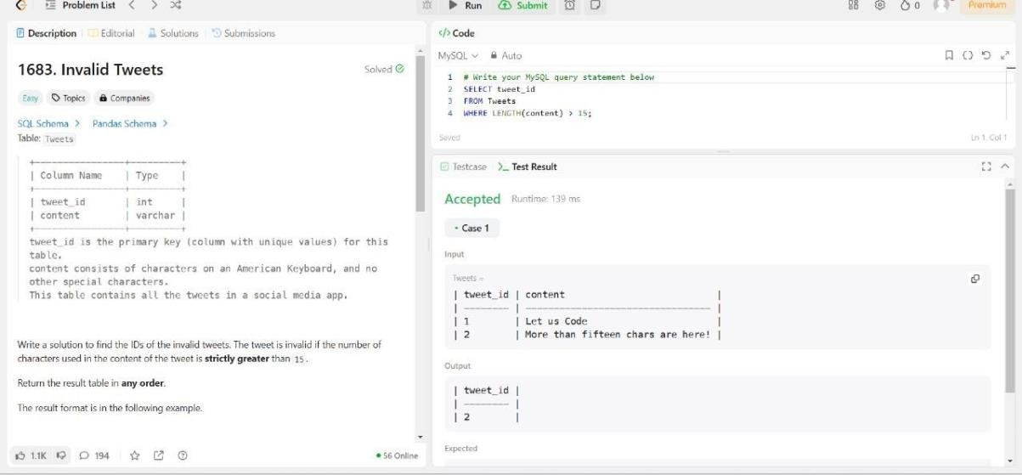

**Case Study Question: School Database**

# Scenario:

You are tasked with designing a database for a small school. The school has students, teachers, and classes. The database should help manage the following information:

1. Students' details: Unique ID, name, age, and grade level.
2. Teachers' details: Unique ID, name, and subject specialization.
3. Classes: Each class has a unique ID, subject name, and a teacher assigned.
4. Enrollments: Students enrolled in specific classes.

# Tasks:

1. **ER Diagram**: Design an ER diagram showing the relationships between Students, Teachers, Classes, and Enrollments.(**Use SmartDraw Tool**)

# Schema Design:

Write SQL to create the following tables:

* + Students (StudentId, Name, Age, GradeLevel) o

Teachers (TeacherId, Name, SubjectSpecialization)

* + Classes (ClassId, SubjectName, TeacherId) o

Enrollments (EnrollmentId, StudentId, ClassId)

Ans. 1)

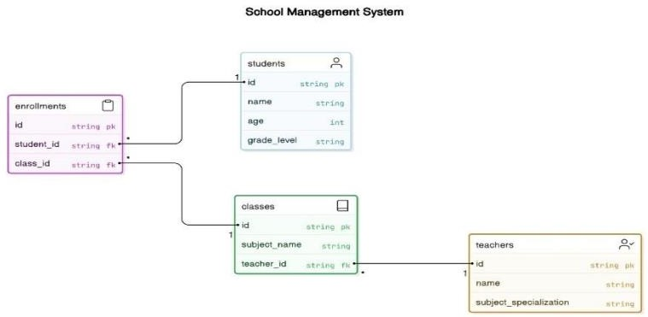

2)

